At Kukadi Valley Public School, holistic education is designed to cultivate every dimension of a student's growth—intellectual, emotional, social, and physical. To support this well-rounded development and nurture personality, the school offers a variety of enriching activities:
- Creative Arts
- Drawing and Painting: Foster imagination and allow students to express themselves visually.
- Drama and Theatre: Strengthen self-confidence and enhance verbal and non-verbal communication.
- Music and Dance: Promote emotional release, rhythm, and coordination through expressive movement and sound.
- 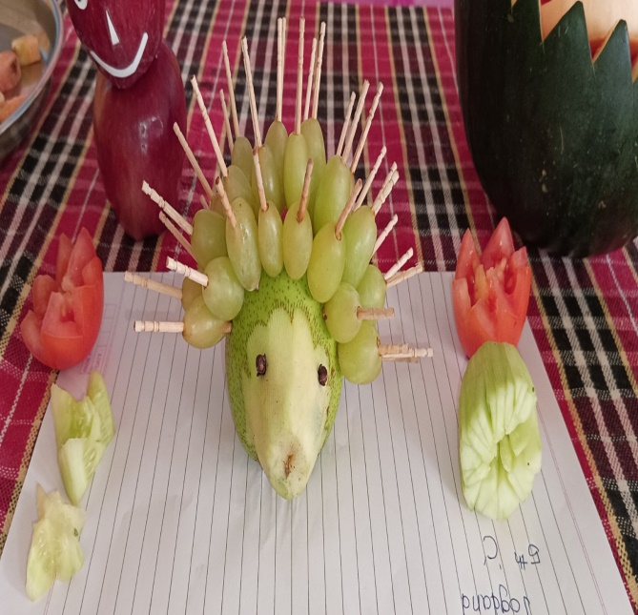

Physical Activities
Physical activities are essential for fostering discipline, resilience, and overall well-being. At Kukadi Valley Public School, these activities are thoughtfully integrated into the curriculum to support both physical health and emotional balance.
- Sports and Games:
Participation in team sports like football, cricket, volleyball, and athletics helps students develop:
  - Teamwork and collaboration: Learning to work with others toward a common goal.
  - Discipline and perseverance: Following rules, practicing regularly, and striving for improvement.
  - Physical fitness: Enhancing strength, stamina, and coordination through active movement.

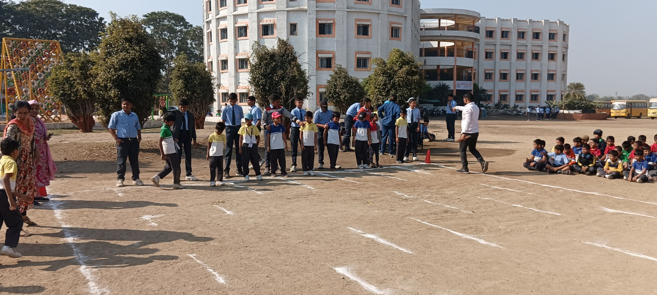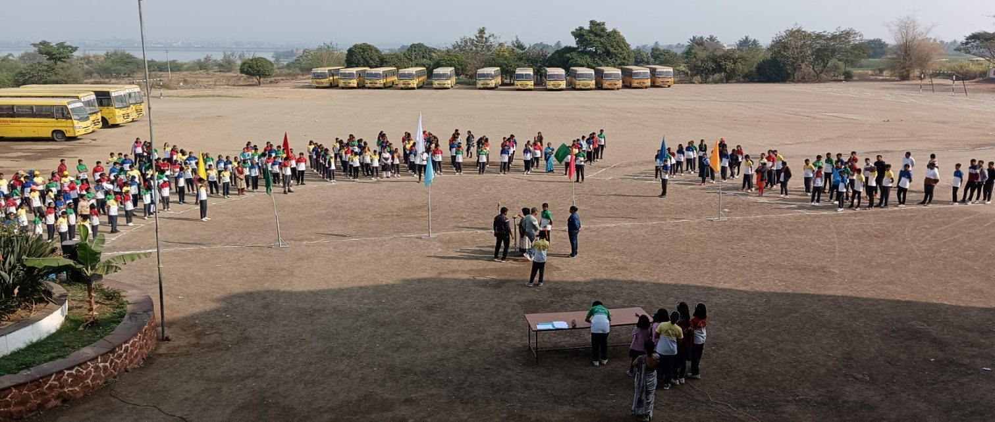
- Yoga and Meditation:
These ancient practices are introduced to students to nurture inner peace and mental clarity:
- Improved concentration: Regular practice helps sharpen focus and attention span.
- Stress reduction: Breathing techniques and mindfulness calm the nervous system.
- Emotional well-being: Students learn to manage emotions and build resilience through self-awareness.

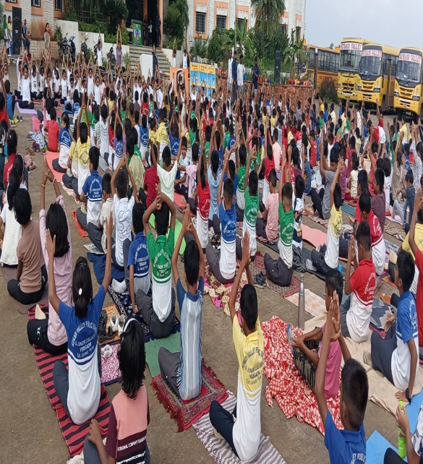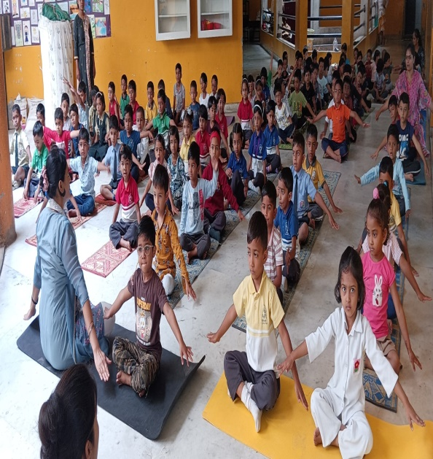

Social and Emotional Learning
Social and emotional learning equips students with the skills to navigate relationships, manage emotions, and contribute positively to society. Kukadi Valley Public School integrates the following activities to nurture empathy, responsibility, and communication:
• Role-Playing Activities: Encourage students to step into others' shoes, helping them understand diverse perspectives and develop empathy.
• Group Discussions and Debates: Sharpen critical thinking, boost confidence, and enhance public speaking abilities through structured dialogue and respectful argumentation.
• Community Service Projects: Instill a sense of civic duty and social awareness by engaging students in meaningful service initiatives that benefit the local community.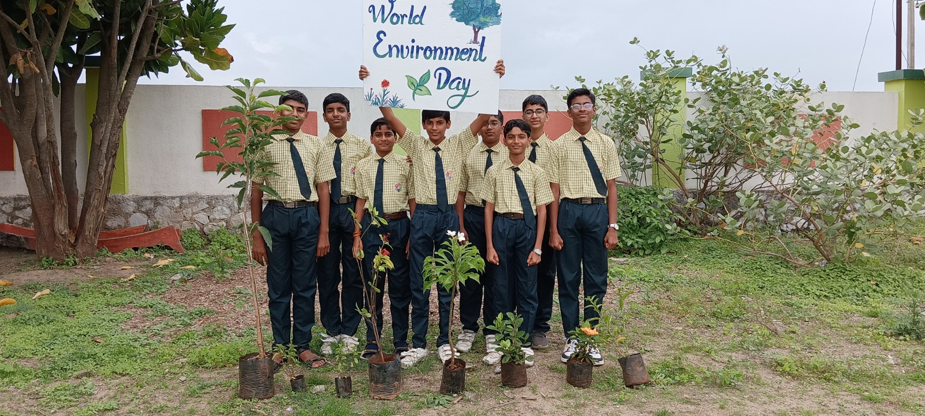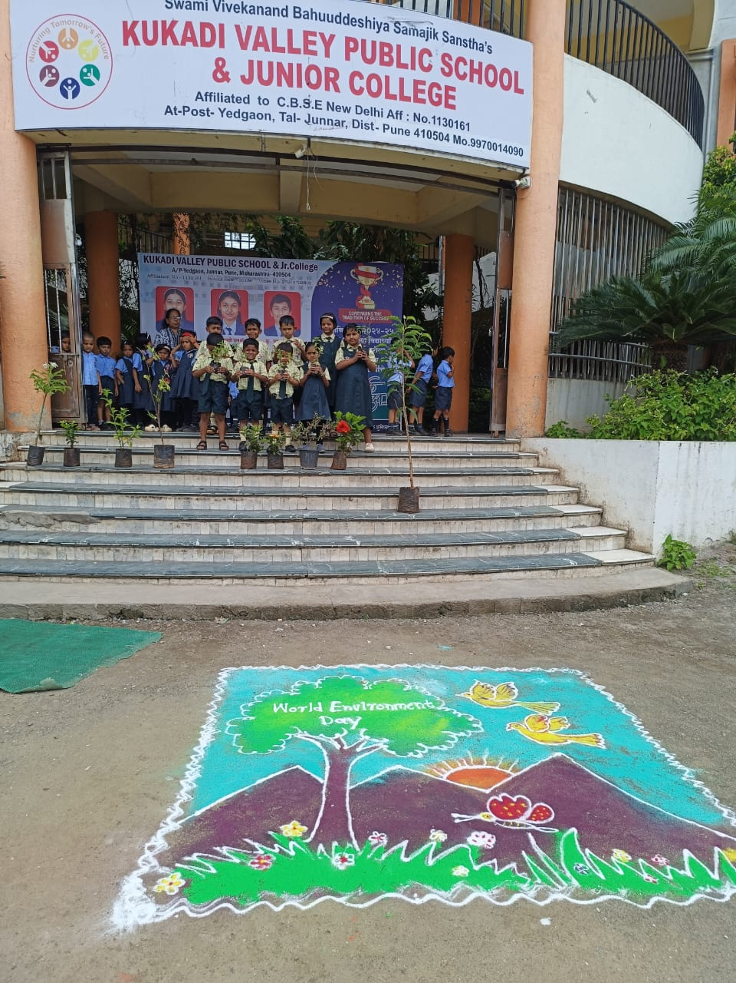

4. Intellectual Development
- Reading and Writing Workshops: Enhance literacy and communication skills.
- Science and Math Clubs: Encourage problem-solving and analytical thinking.
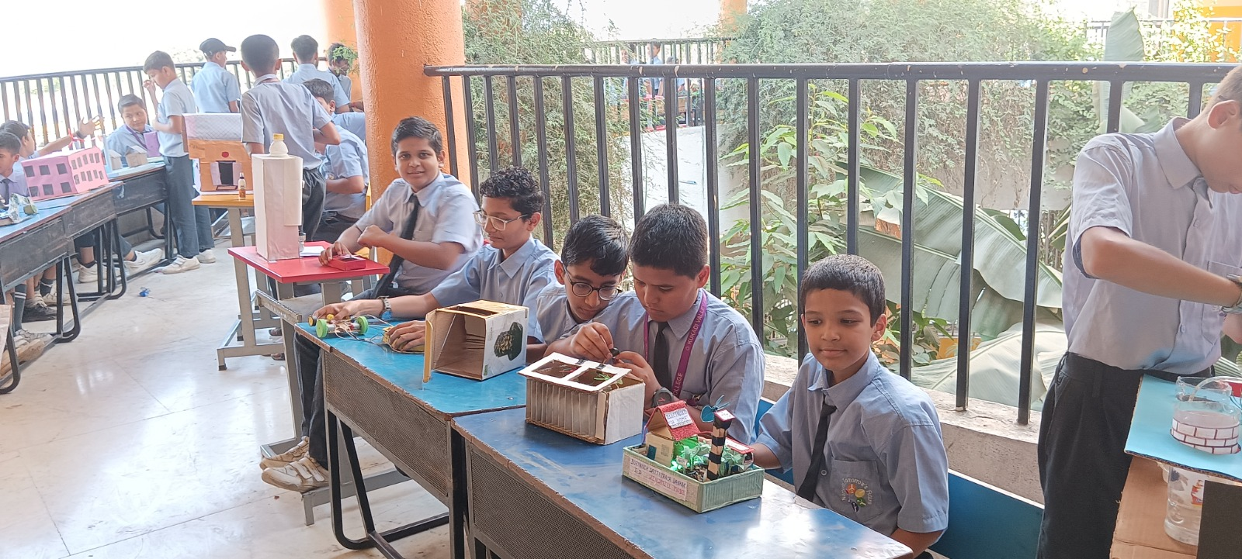

- Coding and Robotics: Develop technical skills and creativity.

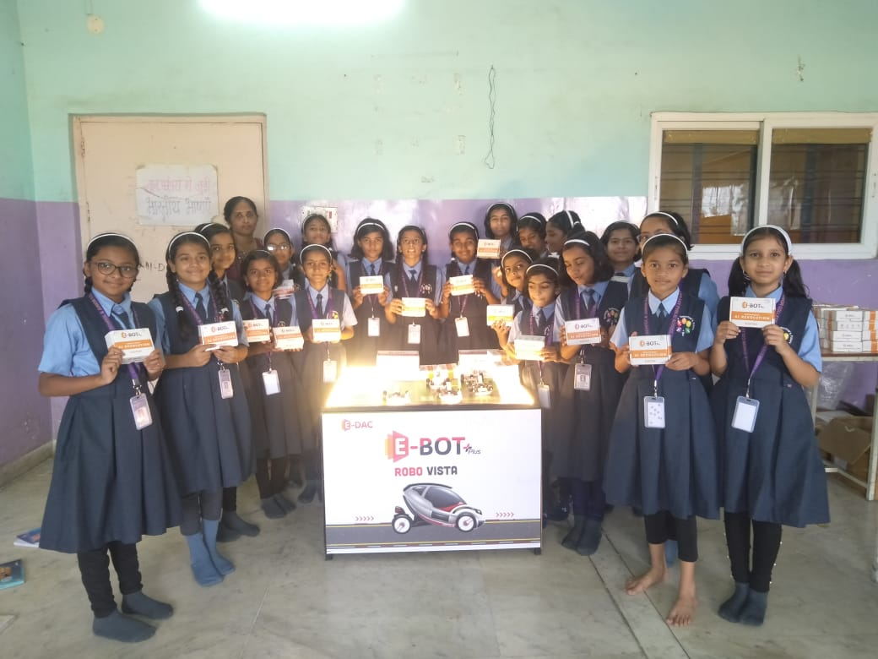

5. Life Skills
- Cooking and Gardening: Teach practical skills and promote healthy living.
- Financial Literacy Workshops: Help students understand money management.
- Time Management and Goal Setting: Equip students with tools for personal and academic success.
6. Mindfulness and Self-Reflection
- Journaling: Encourage self-awareness and emotional expression.
- Mindfulness Exercises: Help students stay present and manage stress.

7. Cultural Activities
- Cultural Exchange Programs: Broaden students’ horizons and promote cultural understanding.
- Festivals and Celebrations: Foster a sense of community and appreciation for diversity.