Governance,Processes,Teaching /Learing Process
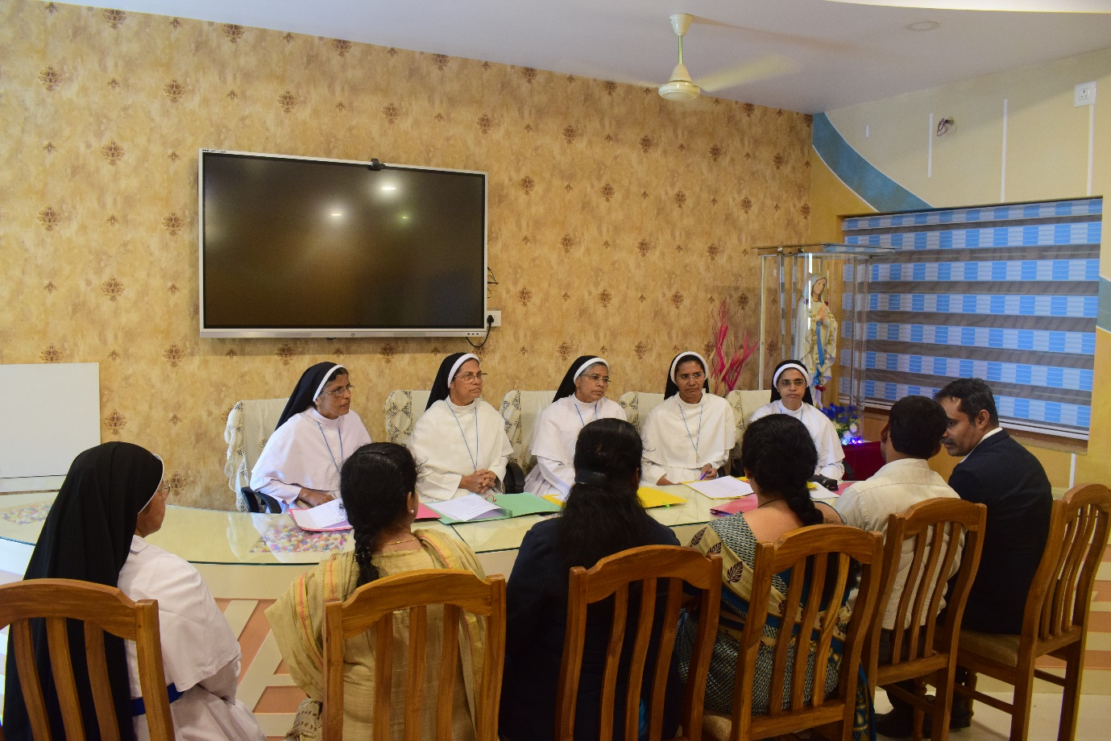
SCHOOL MANAGEMENT COMMITEE

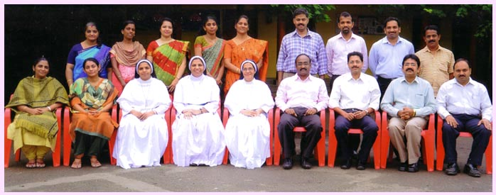
SCHOOL PARENT TEACHERS ASSOCIATION

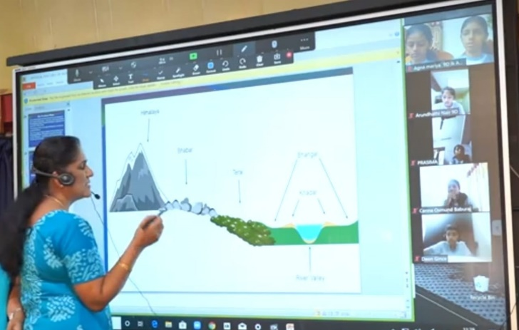 DIGITAL BOARD

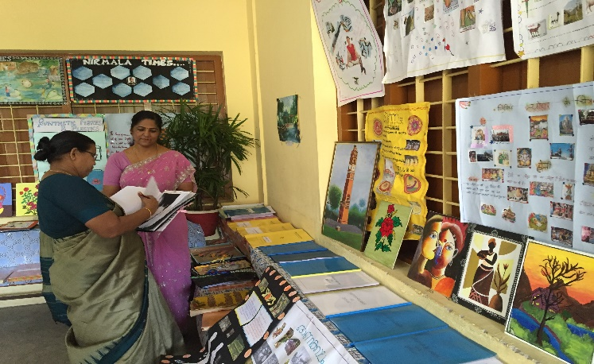 Mentoring Monitoring Programme

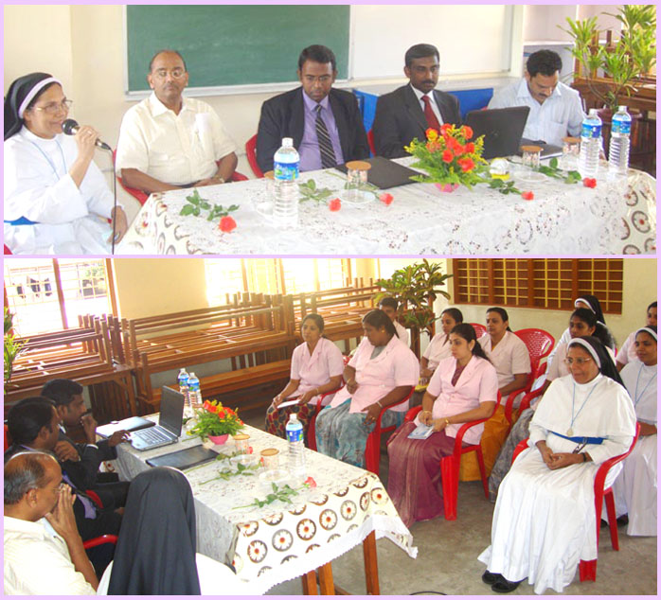 ISO AUDIT

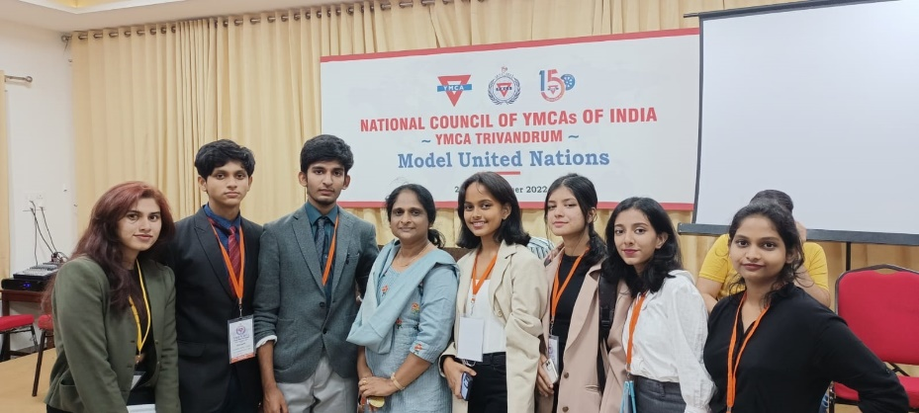 Model United Nations

