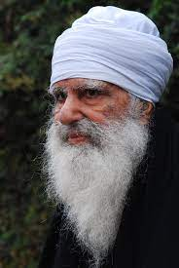

https://www.tribuneindia.com/news/himachal/renowned-social-worker-and-padma-shri-awardee-baba-iqbal-singh-passes-away-at-96-in-baru-sahib-365340
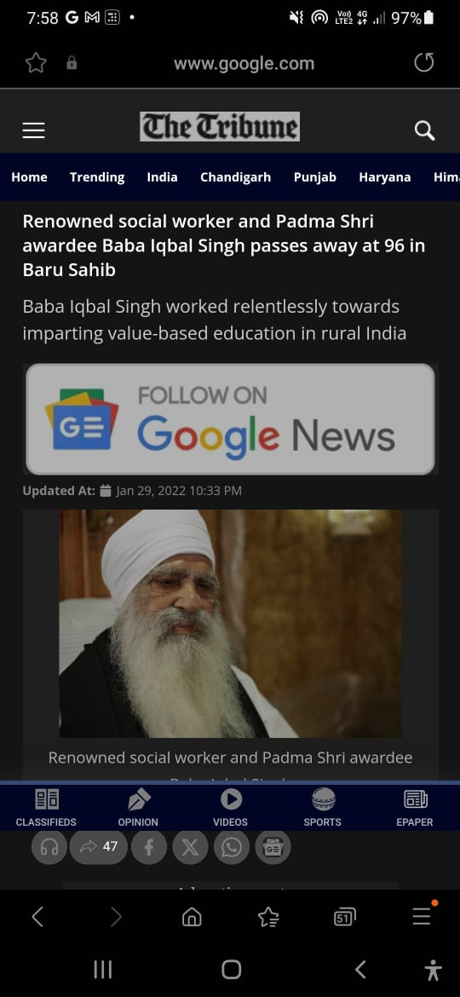 | 

