Orientation Programme for Parents
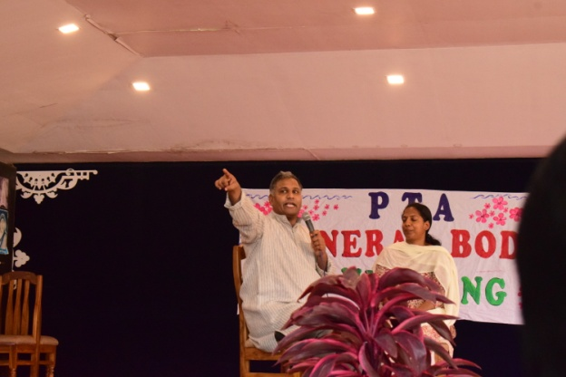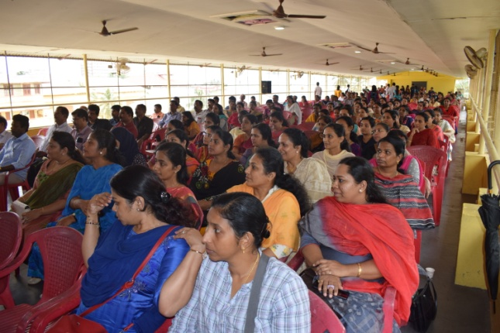

Seminar on Parenting
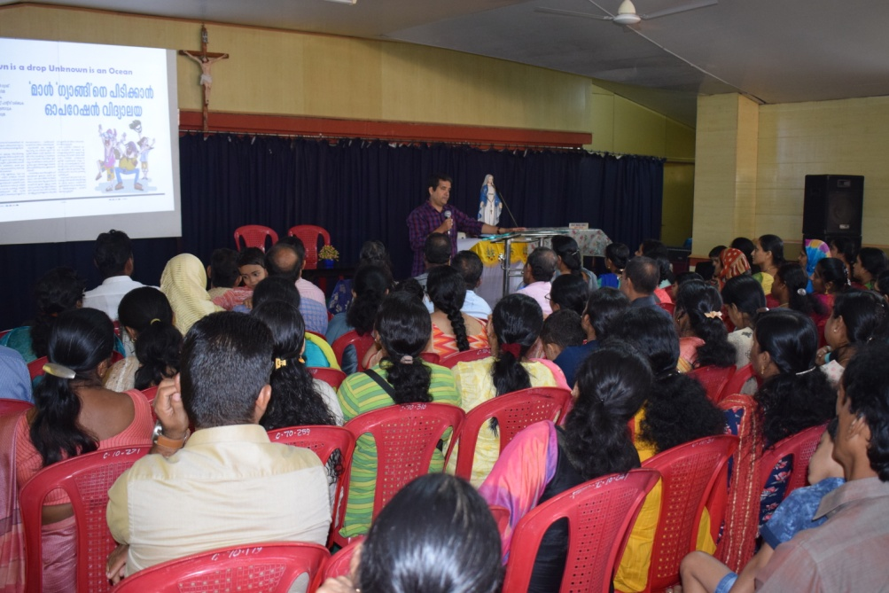

REPORT OF CLASS PTA
STD: XI
Venue: Mar Thomas Kurialassery Hall
Date: 25/07/2023
Time: 2.00 pm – 3.00 pm
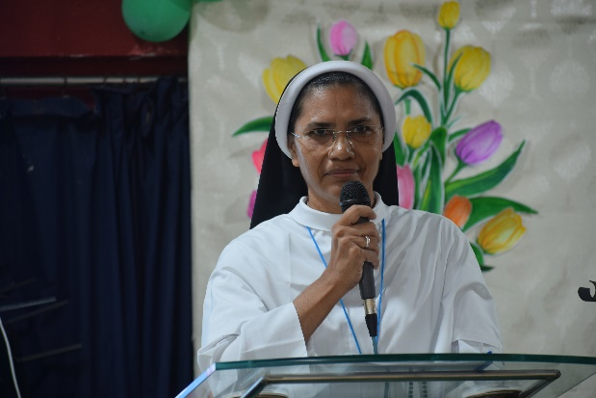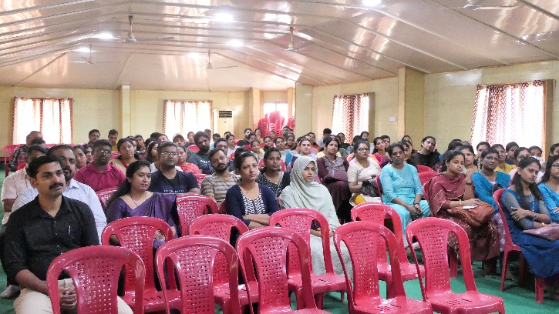
Meeting started with a prayer song, followed by welcome speech by Ms. Elizabeth. Meeting continued with the experiences and the thoughts shared by the school counsellor mrs.Vini Paul.After the motivation class, Ms. Elizabeth gave a brief on instructions regarding pattern of std. XI examinations. Principal Sr. Linsa Maria addressed the gathering and told the parents about the importance of being their child’s strong support. Then parents were asked to provide the suggestions and feedback. Finally a male parent Mr.Sabu V.V.(parent of Joshua Sabu XIA) is selected as a PTA representative for this academic year(2023-24). After that, std XI C and D parents, teachers had a small discussion with Sr. Principal regarding early morning classes for different subjects. Meeting ended with a silent prayer.

Suggestions
- Rule of language must be mandatory.
- Canteen facility must be improved.
- School uniform shawl can be replaced with coat.
- Improve mathematics and physics classes.

Principal

