
Hansraj Public School, Sector- 6, Panchkula

Self-Assessment

Name of the Activity: ___________________________ Date: _______________________
Description: ________________________________________________________________
Parameter | Happy doing it | Just fine | Need to be better
I enjoyed doing the activity | 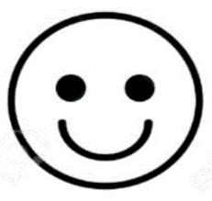 | 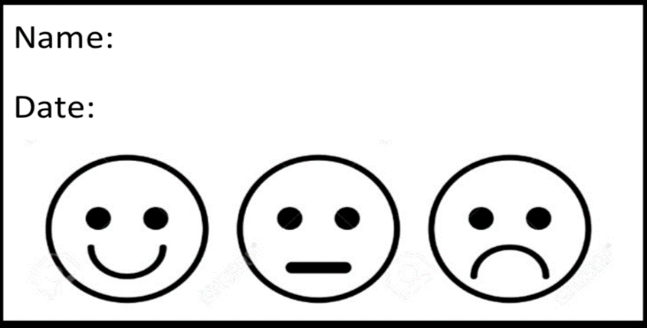
I completed all the tasks independently
I completed my task on time
I feel I did my best

Star Rating:

Remarks: ____________________________________
____________________________________________

Teacher’s Signature

