Q 1 – The school is following 5S technology in School.
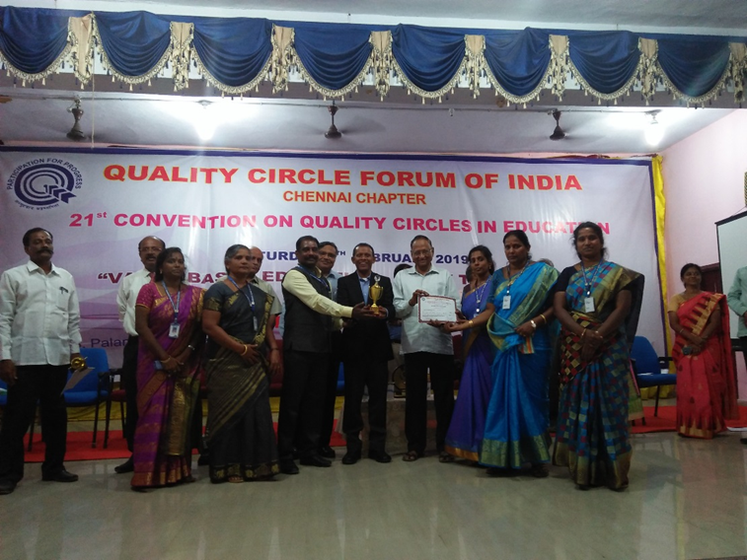
The school received best 5S Practicing School from Quality circle forum of India and ABK –AOTS award – It is a State and National Award.
15 teachers are qualified as Internal Auditors.
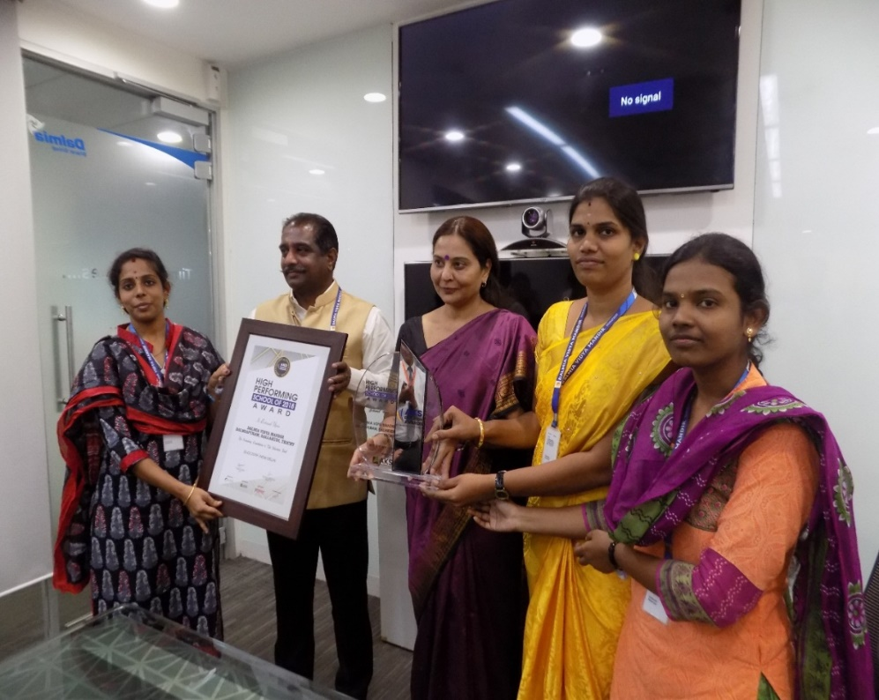
- A mile stone in our achievement is AKS AWARD for High Performing School. For this prestigious award, Our school had been selected out of five countries and 29 states from our country.

