
Hansraj Public School, Sector- 6, Panchkula

Peer-Assessment

My Friend’s Name: _____________________________
Name of the Activity: ________________________________________________________
Description: ________________________________________________________________
Parameter | Happy doing it | Not so excited | Didn’t enjoy it
I enjoyed the task | 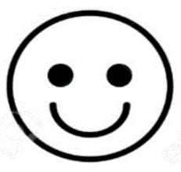 | 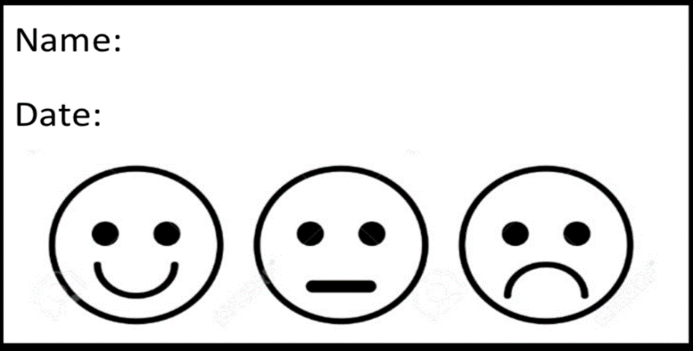
My friend completed task on time
My friend was loud and confident

Star Rating:
Remarks: ____________________________________
____________________________________________

Remarks: ____________________________________________

Name: _________________________ Teacher’s Signature

