
Hansraj Public School, Sector- 6, Panchkula
Feedback from Parent/Caregiver

Name of the Activity: ________________________________ Date: __________________
Description: ________________________________________________________________
Parameter | Level of proficiency
My ward enjoyed the activity and did it with enthusiasm. | 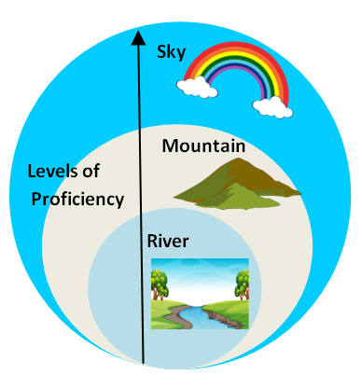
My ward did the task independently and completed it on time.
My ward displayed awareness about the topic and learnt new things.
My ward displayed creativity.
My ward exhibited confidence and did his best.

Levels of proficiency
Sky (Red)- Always Mountain (Green) – Usually River (Blue) – Sometimes/ Needs Help
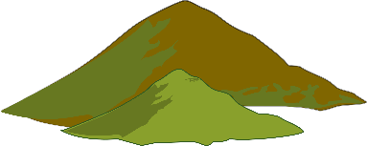

Feedback: __________________________________________________________________
___________________________________________________________________________
___________________________________________________________________________

Name of the child: ______________________ Class: _____________________
Parent Name: __________________________

Parent Signature Coordinator Signature

