Whether the school has a Quality Culture, Efficient and Improved Work Environment, Scientific and Systematic approach towards Teaching, Continuous Learning and Training for Staff?

Academic Calendar
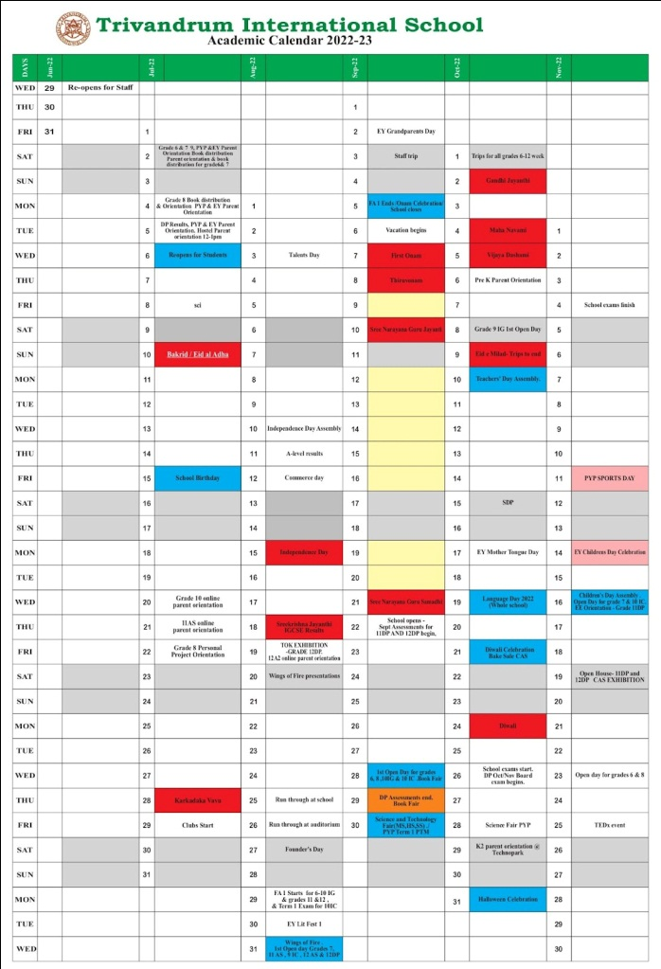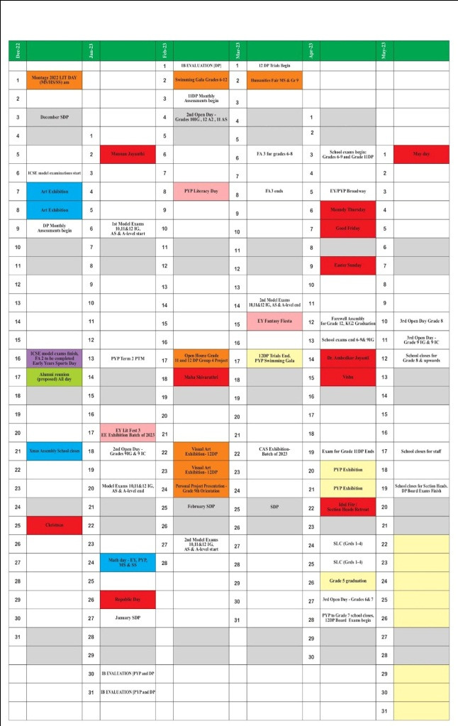

Monthly Staff Development Program

