Whether the school provides holistic / balanced education that helps students for Personality Development?
Exchange program - German students visit in 2018-19
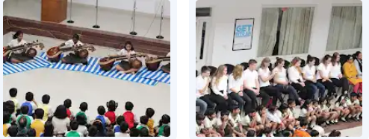
Timetables:
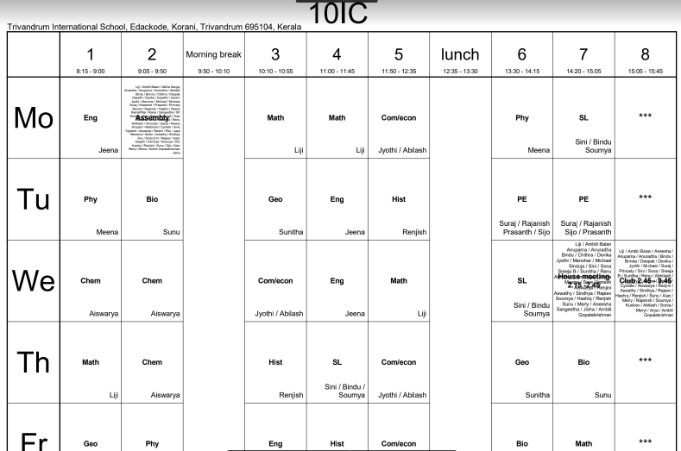
grade 6
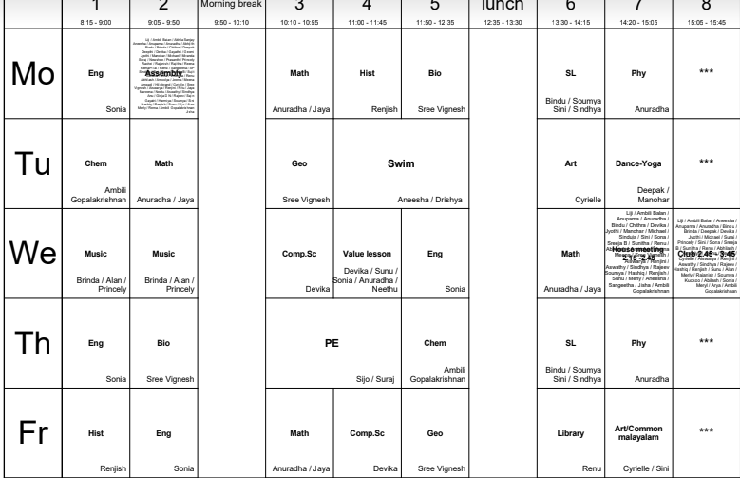
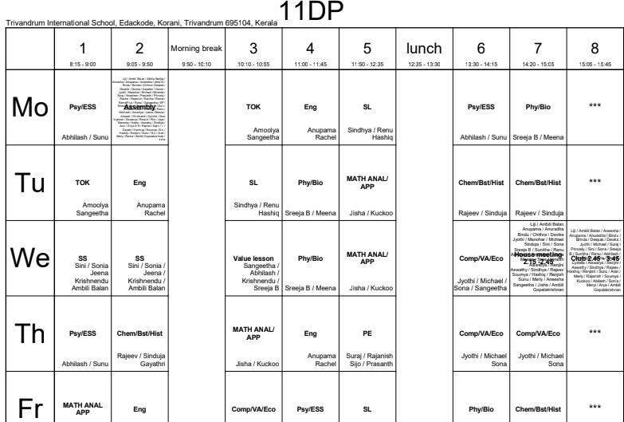
Grade 5
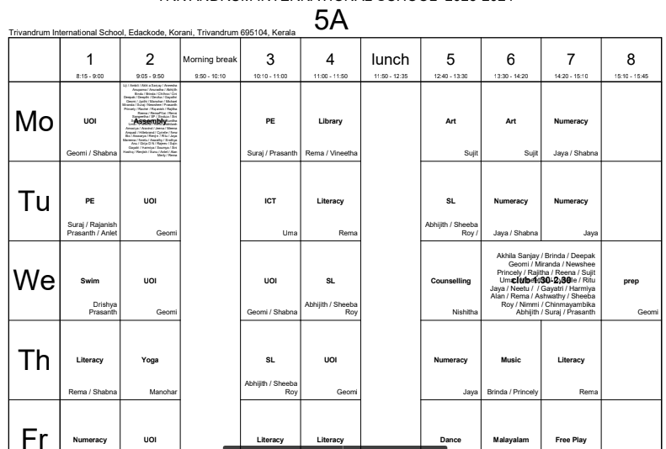
North Paravur School Renovation - CAS activity
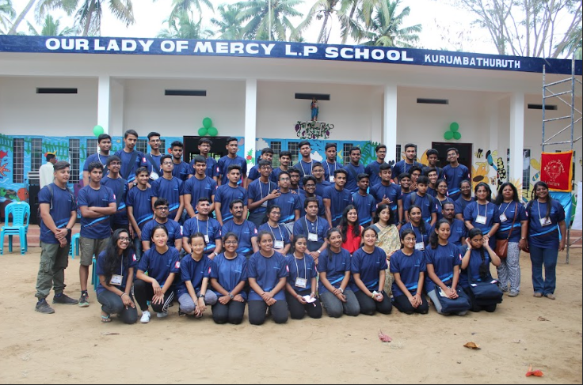

Wings of fire
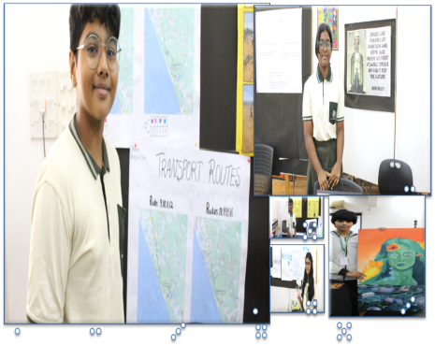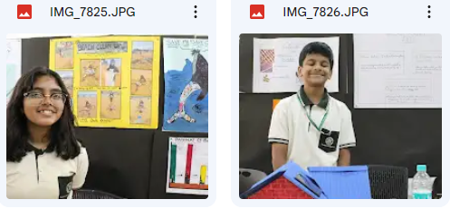
Personal Project
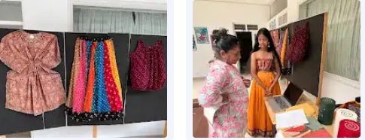
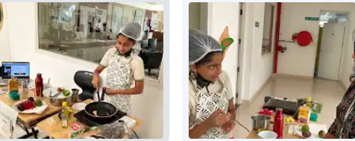
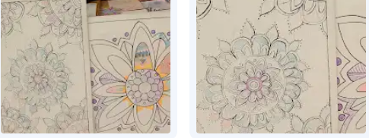
Social Service Culmination - The students from the primary Government school visit TRINS for a culmination program where they demonstrate what they learnt from the senior students of Trins. 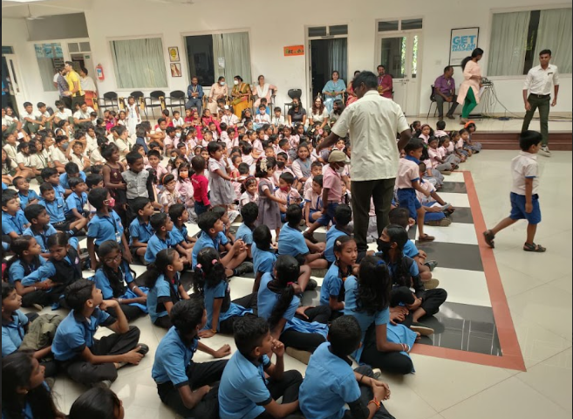
CAS/ SEN activities
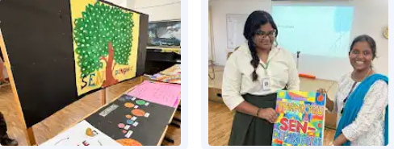
Class trips: Leadership camps (INME - Youreka )
These outdoor classes have the students inspired in group work and teach about leadership in very subtle but sure ways. All the classes from the grade 6- 12 were given the opportunity to join the camps.

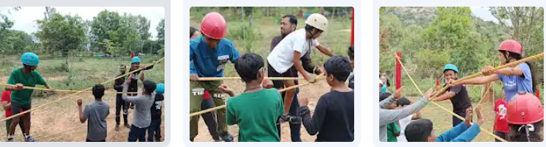
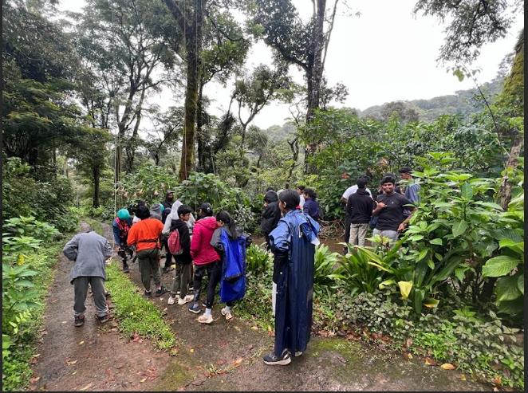

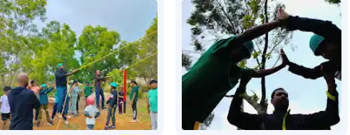

Broadway - Theatrical productions
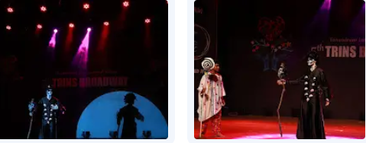
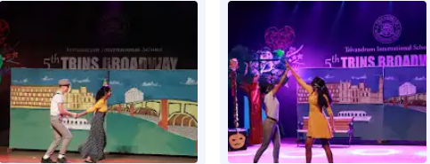
Proceeds from the bake sale were donated as diapers to the Ward 9 of General hospital.
