Whether the school has National/ International recognition for Quality Standards? (Not more than 250 words).

International Dimension in schools 2022-25.
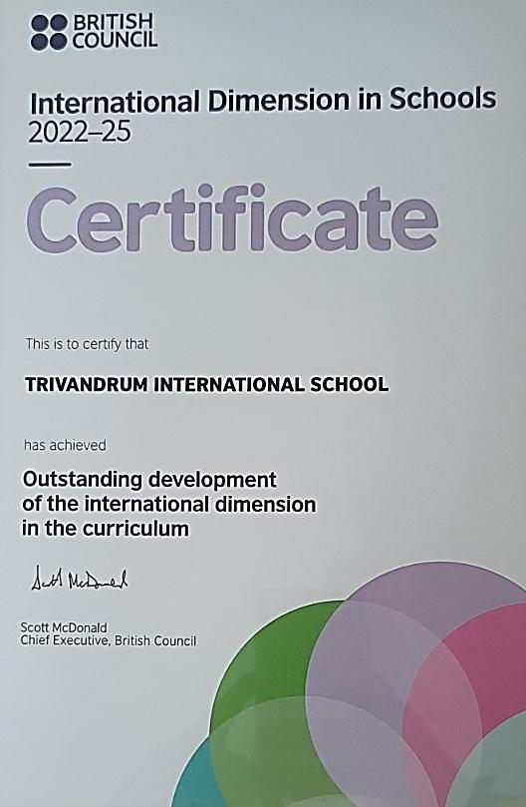

Ms. Sapnu George, TRINS Executive Director, collected an award from the publication ‘Education Today’ for TRINS being identified as the best day-cum-boarding school in Kerala

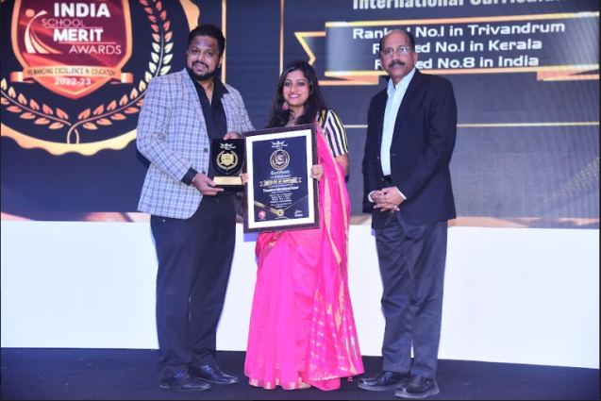

Ms Sapnu George , Executive Director TRINS got awarded with Outstanding Director of the Year 2020.
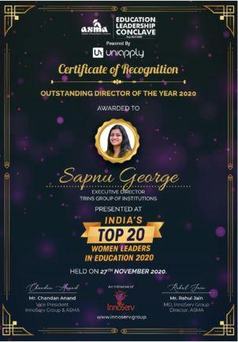

Mr Richard Hillebrand, our Principal, for being awarded the Citation of Eminence from Lifology, a Guinness World Record winning Ed-tech organisation. The eminent 50 were selected from 1000 Indian schools across India and the Middle East.

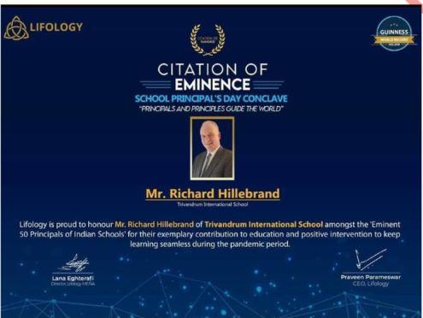

- Ms Sini collected Special Educationalist of the Year (regional)
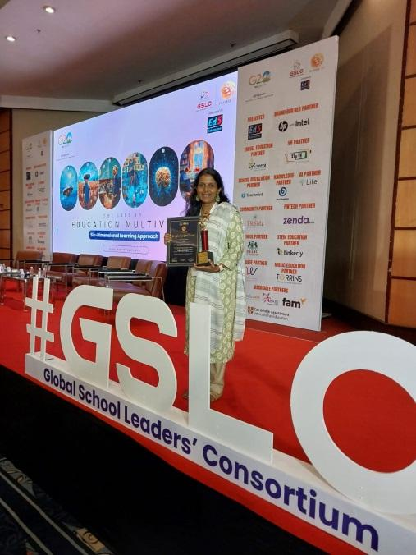

- Ms. Anuradha has been placed in the top 10 of the Suraasa Teacher Impact awards. 68,000 teachers entered the international award process.

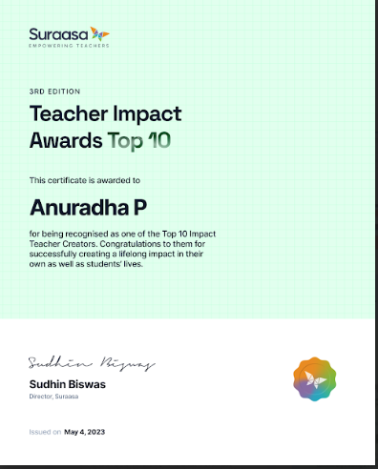

Re think India India Harnarian Kantidevi Musical Research Centre has conferred upon Ms Brinda the M S Subbalakshmi Sangeet Samaan 2021 for her inspirational work as a Music teacher.


Trivandrum International school is a Global Member of Round Square and is a member of Young Round Square.
