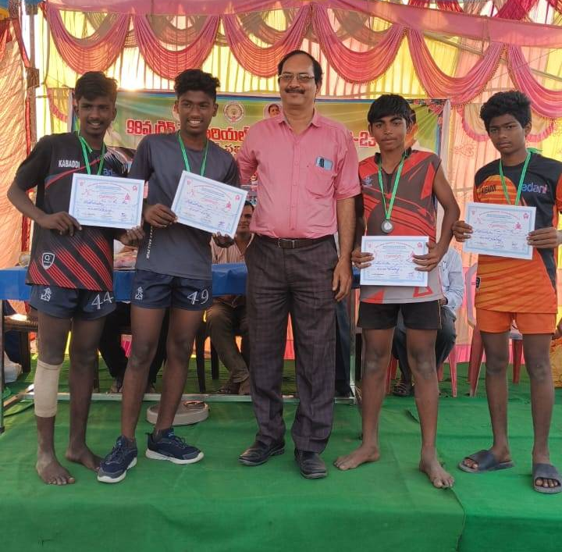
(AVMK Students participated in GRIG Memorial Tournament 2023)
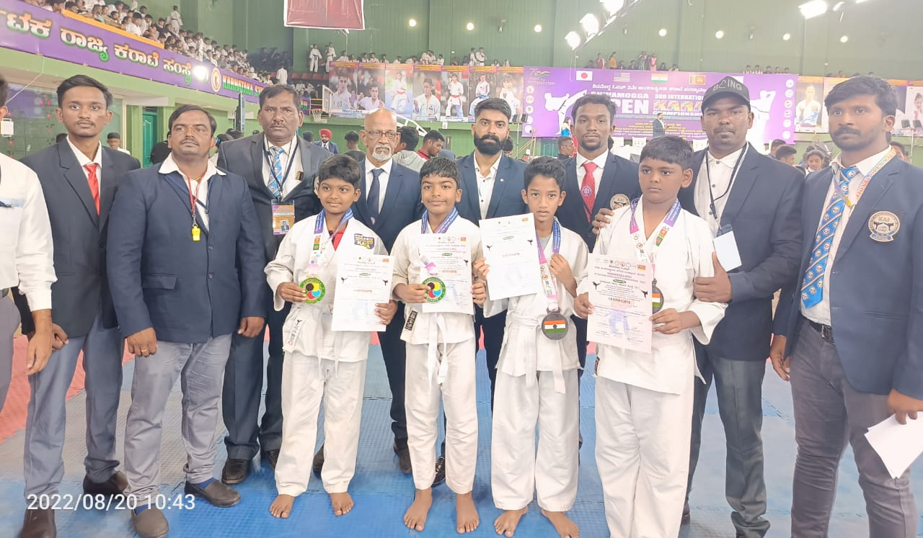
( AVMK Students in SHOBUKAI CUP -2022 South Indian Open Karate tournament )
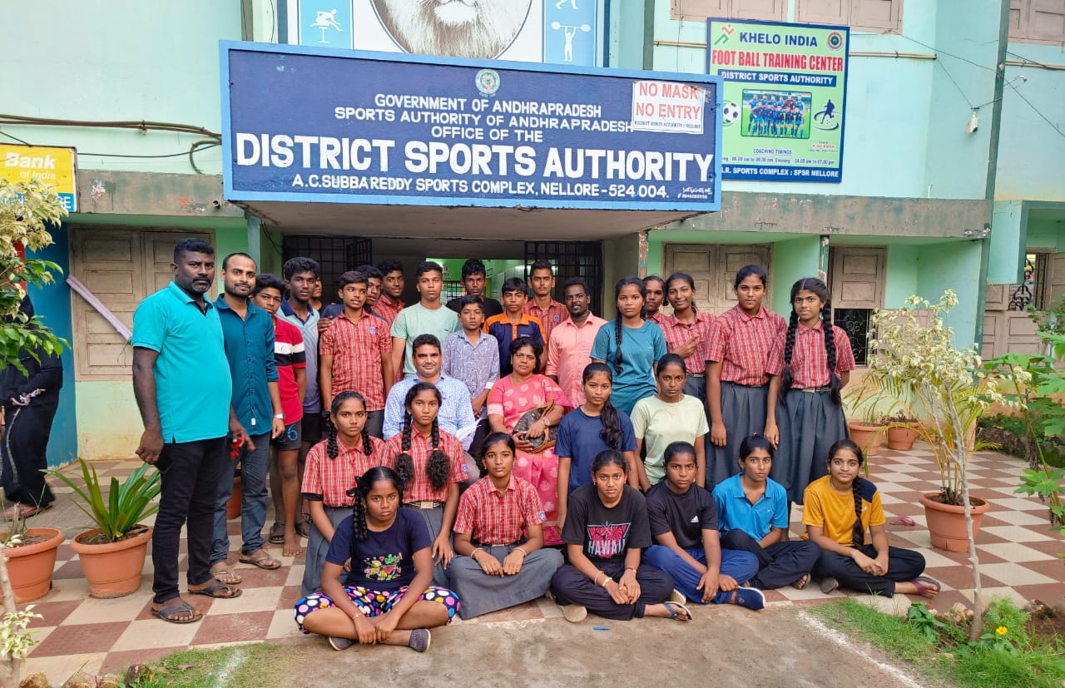
( AVMK Students at A.C Subbareddy Soports Complex Nellore )

