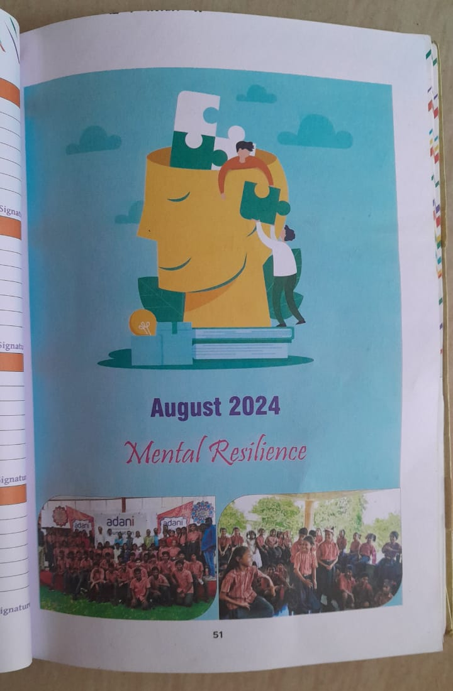
(August month Theme mentioned in Student Diary)
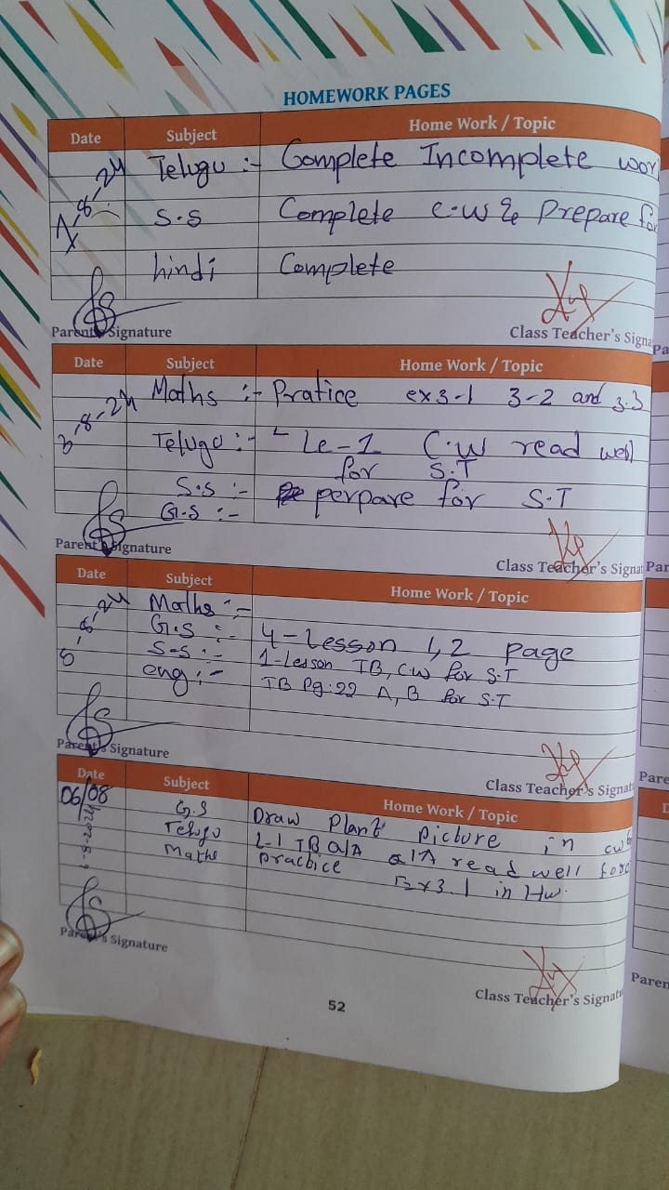(Student diary-day wise homework information)

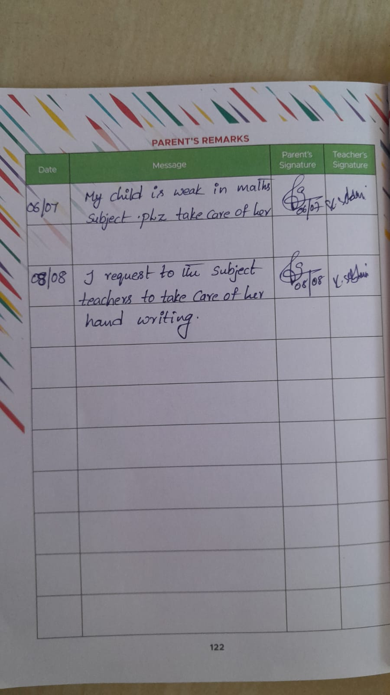
(Remarks written by a parent on Child’s performance)

