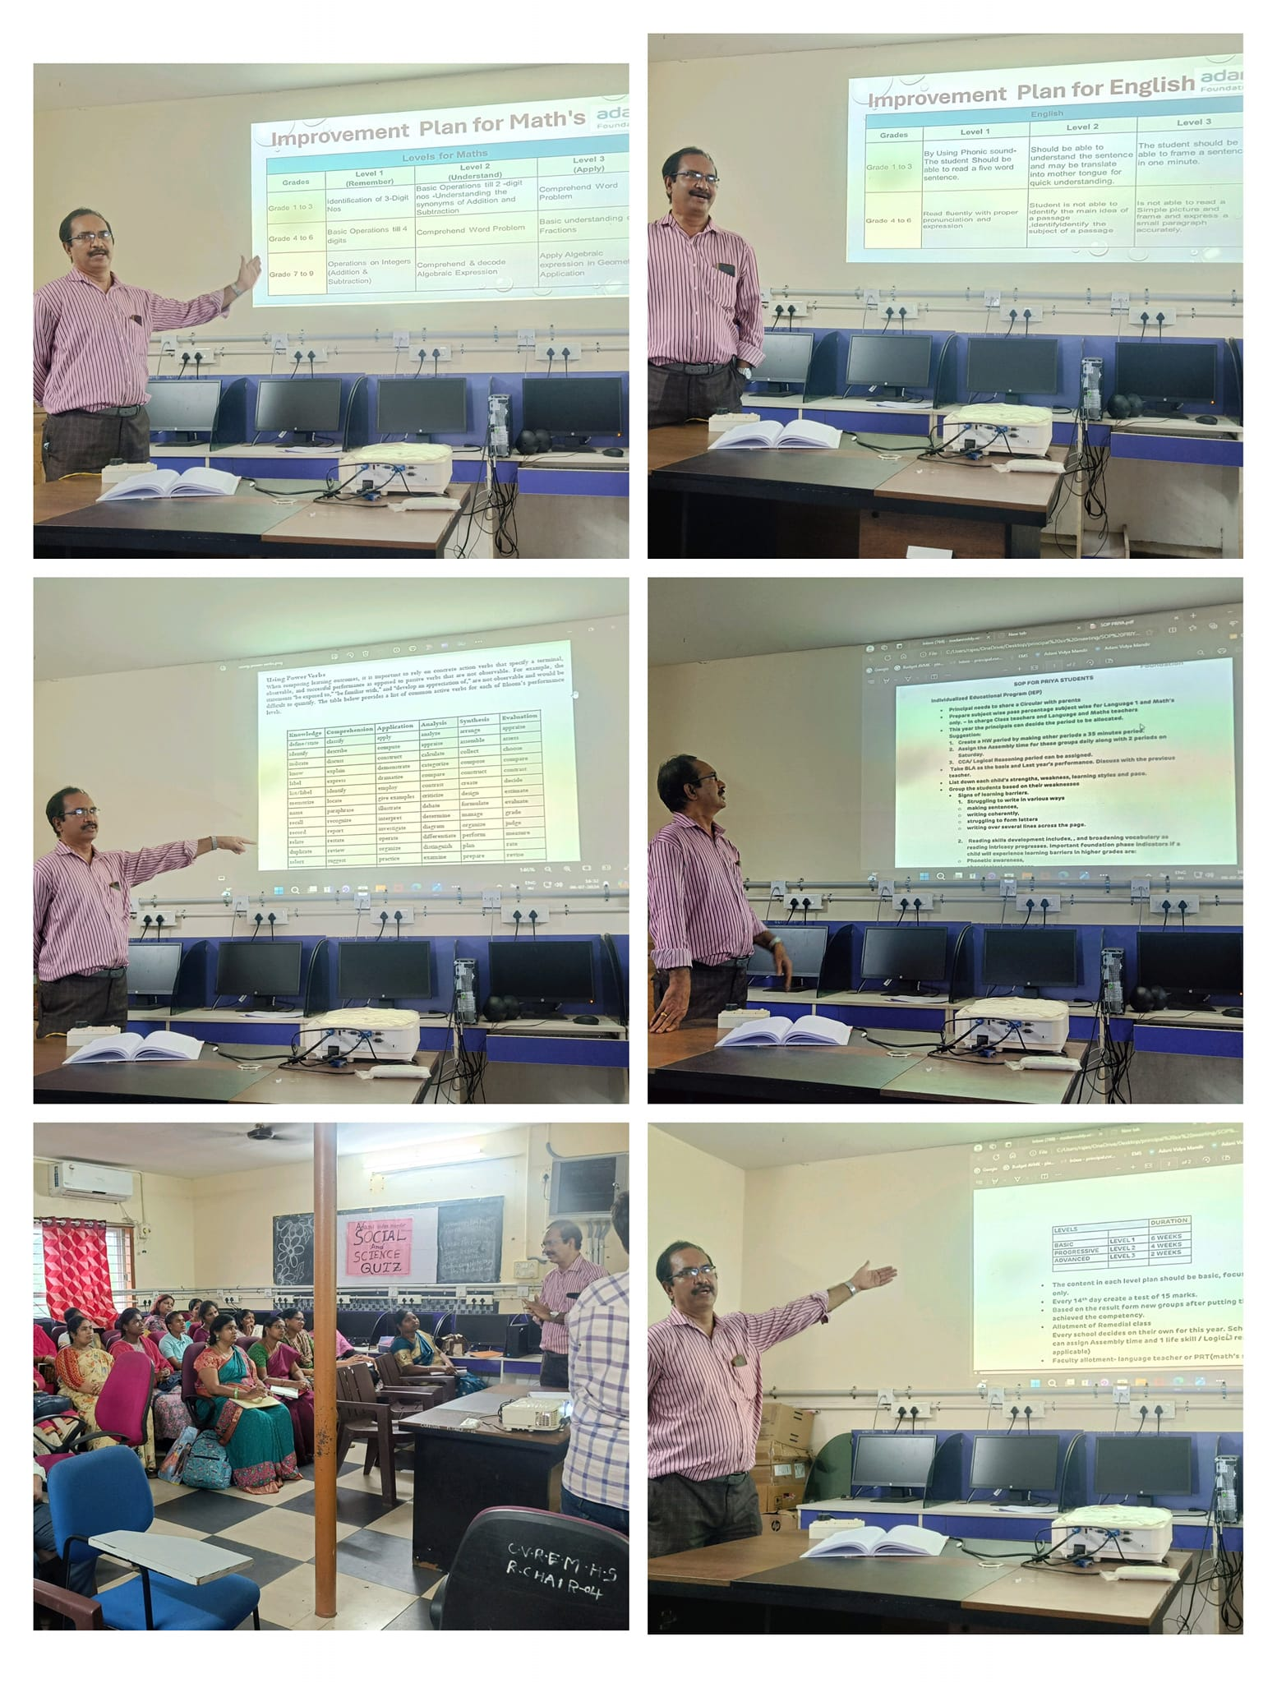
Workshop on how to improve progressive Learners by Principal (J Srinivasa Rao)

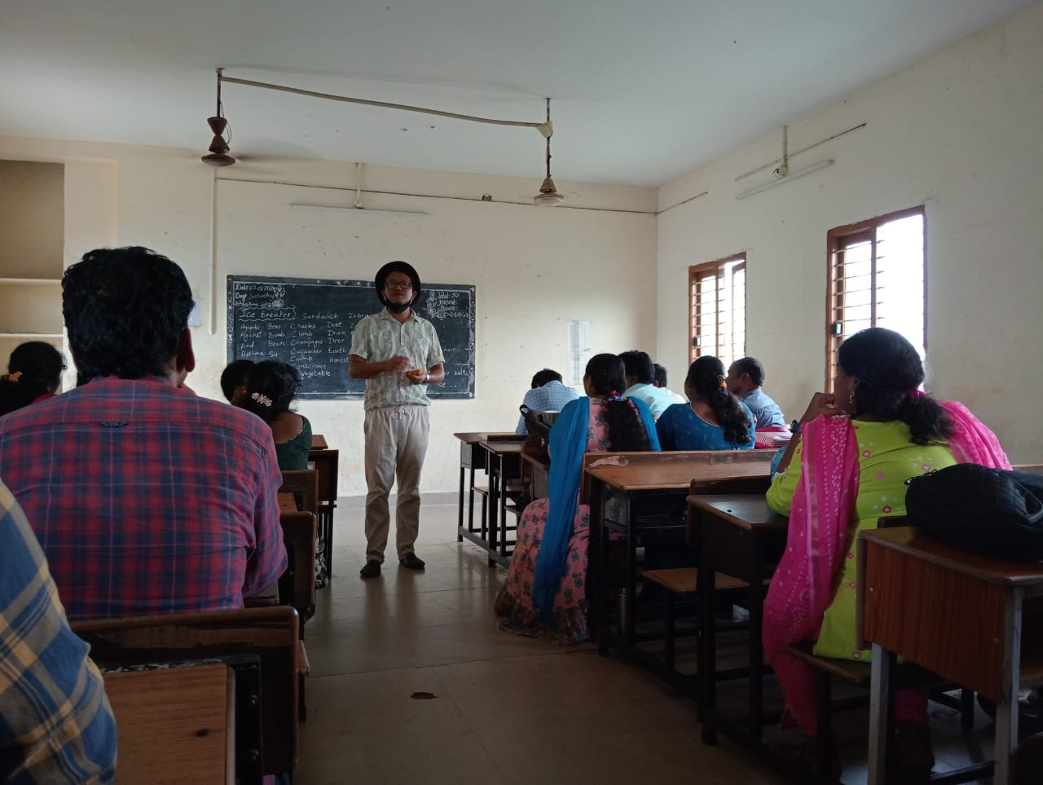
Workshop on Communication Skills for Teachers by Co-ordinator (Sunny Damien Bomjan)

